BackBone Thesaurus -
Submission and Connection Management Tool

Quick User Guide

Version 2.0

Contents
Back Bone Thesaurus Tab 3
Back Bone Thesaurus – tree view 3
BBT term form - view mode 4
Submissions Tab 5
Submissions list description 5
Create a new submission 7
Search for submissions 8
Connections Tab 10
Connections list description 10
Search for connections 12

Back Bone Thesaurus Tab
Users can browse and search the BBT terms of the official release of the BBT as well as older versions, using the Back Bone Thesaurus tab-section.
Each term can be viewed by a term form with all the related information. It is possible to make submissions for changes on specific terms and additionally connect those terms with local thesaurus terms. Finally, a functionality of BBT version comparison is provided.

Back Bone Thesaurus – tree view
Related user role: all (applies to all the section apart of paragraphs with other indication in the beginning)
When the Back Bone Thesaurus tab-section is selected the tree of the BBT terms appears (Figure 1). “Facets” appear in a dark grey line, while the “top term” of the facet itself appear in a lighter grey line. All terms that belong under a facet (“hierarchies”), appear in a light colored line beneath the facet. All lines in the BBT tree are links that lead to the term forms. On the right side of each term line are placed two buttons: one for creating a new submission on the specific term (blue cross button) and one for creating a new connection with a local thesaurus term (orange cross button).
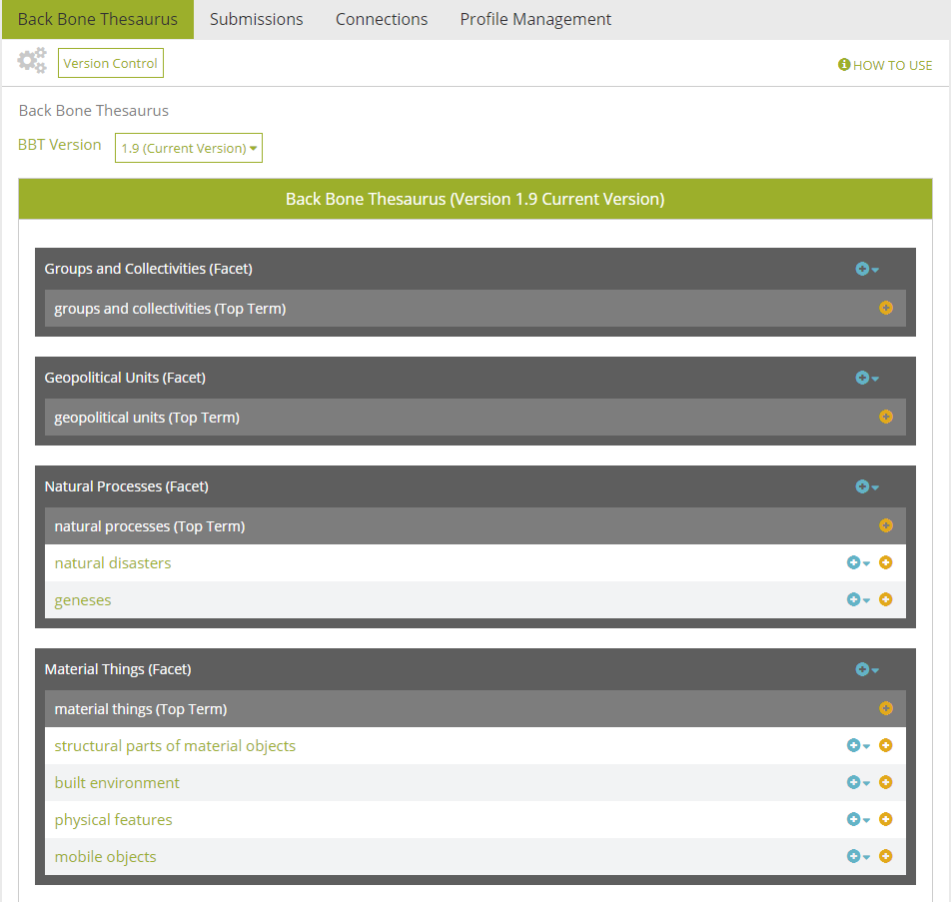
Figure 1: Back Bone thesaurus – tree view

BBT term form - view mode
Related user role: all (applies to all the section apart of paragraphs with other indication in the beginning)
In the tree of the BBT terms each line is a link that on click will lead to the BBT term form (Figure 2). A term form includes information related to the term such as: Label, URI, Scope Note, Facet, Broader, Narrower Term Examples
Underneath the basic information are located the buttons for making a new submission to the specific term, or for connecting the BBT term with a term of a local thesaurus. Next to each button exists a link, which opens the list of all related submissions to the term and the list of all related connections respectively.

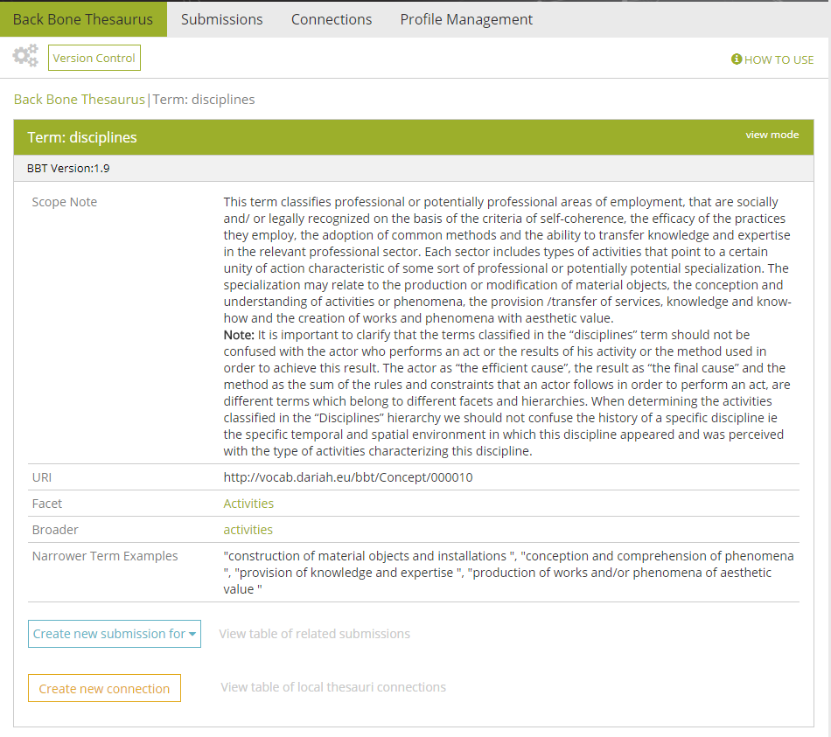
Figure 2: BBT Term form

Submissions Tab
Users can create a new Submission (request for change) for a BBT term, using Submissions tab-section. Users can also search, view and comment own and other user submissions or edit, delete own saved submissions.

Submissions list description
Related user role: all (applies to all the section apart of paragraphs with other indication in the beginning)
When the Submission tab-section is selected, the list of all submission entries appears in the main area (Figure 3). Submissions are listed by most recent entry date.

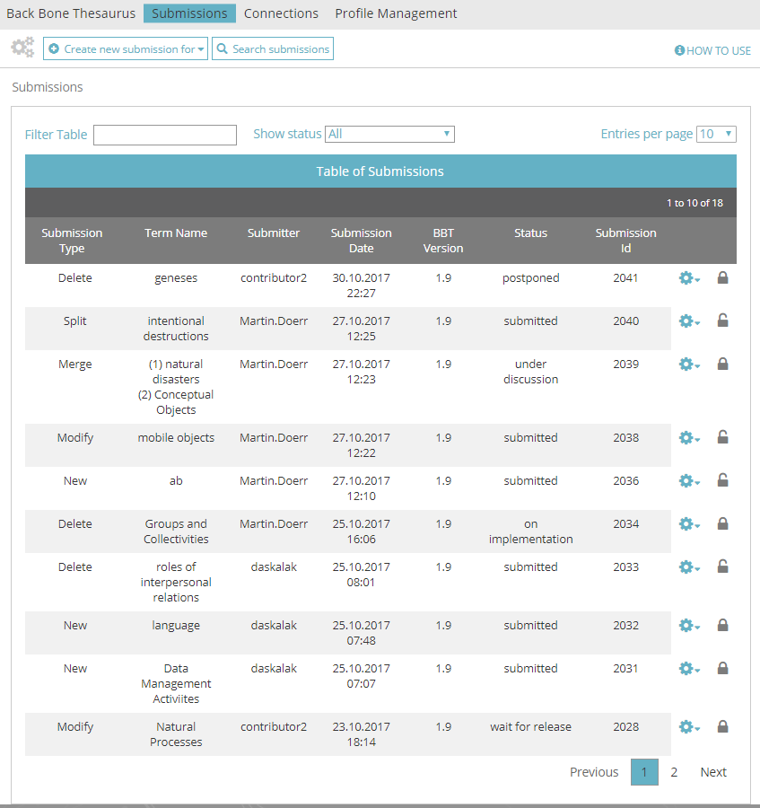
Figure 3: List of Submissions
Each line of the list represents a submission. Each column includes information related to the submissions:
- Submission Type: the type of submission (e.g. proposal for splitting a term).
- Term Name: the term of the BBT the submission refers to.
- Submitter: the user who made the submission
- Submission Date: the date of submission
- BBT Version: the version number of the BBT on which the submission was made.
- Status: the current status of the submission.
- Submission Id: An identification number of the submission given automatically by the system
All submission lines of the list are links that lead to the Submissions form in view mode.

Submissions List Filters
The user can filter submissions either from the filter box on the left top side of the list using keywords related to the field content that appears in the columns and rows of the table (Figure 4) or from the dropdown list on the center top side of the list depending on their status (Figure 5).
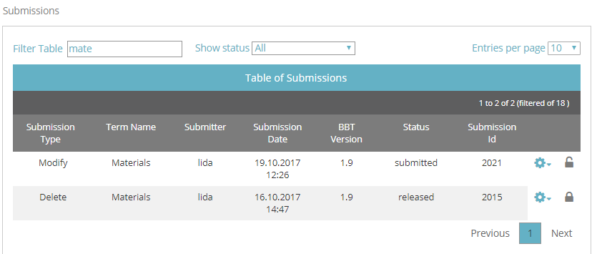
Figure 4: Submissions list filtered by keyword “mate”
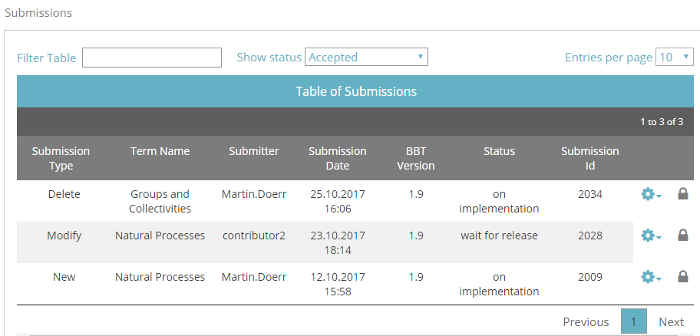
Figure 5: Submissions list filtered by status “accepted”

Submissions List Actions
The user may select to edit or delete one of his own submissions, view the BBT term add a comment to a submission or Forward the submission to a reviewer or the contributor. On the right side of each submission line are the related buttons (Figure 6). Notice that actions depend on the status of the submission and whether the submission is owned by the user:
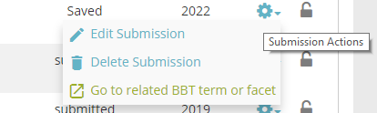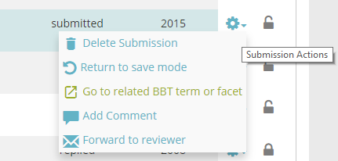
Figure 6: Submission list actions, depend on the submission status
- Edit Submission: (Related user role: owner) this button opens the edit mode of the submission form. Users can only edit their own submissions and only those with status “saved”. (Related user role: administrator) Only administrators have the right to edit other user submissions (with status “saved”).
- Return to save mode: (Related user role: owner) since users can only edit their own submissions with status “saved”, this button enables users to change the status of a submission from “submitted” back to “saved”. (Related user role: administrator) Only administrators have the right to return other user submissions (with status “submitted”) to status “saved”.
- Delete submission form: Related user role: owner) this button allows the user to delete the submission. Users can delete only their own submissions (submissions with status “saved” or “submitted”). A warning message appears by clicking the button. (Related user role: administrator) Only administrators have the right to delete other user submissions (submissions with status “saved” or “submitted”).
- Go to related BBT term or facet: (Related user role: any) this button allows the user to view the BBT term
- Add a comment: (Related user role: any) this button allows the user to add a comment in the submission.
- Forward to reviewer: (Related user role: administrator, curator) this button sends a message to the reviewer. It opens up a pop up screen allowing the user to choose the specific reviewer to which the message should be sent. The message includes a link to the submission and the comment of the user.

Create a new submission
Related user role: all (applies to all the section apart of paragraphs with other indication in the beginning)
In order to create a new Submission, the user has to choose “Create new submission for…” from the top left side of the tool menu. The button expands a dropdown list with the types of submission: actions that the user wants to address in his submission in relation to a specific term. The available submission types are (Figure 7):
- Creating a new term: The user wants to request the addition of a new term to the BBT.
- Deleting a term: The user wants to request the deletion of an existing term of the BBT.
- Modifying a term: The user wants to request the modification of the title or the description (or any other related information) of an existing term of the BBT.
- Merging terms: The user wants to request the merge of two existing terms of the BBT.
- Splitting terms: The user wants to request the split of an existing term of the BBT into two separate terms.
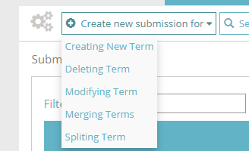
Figure 7: Options for creating a new submission
The Submission forms vary depending on the submission type. The general structure is the same but some fields might differ.

Search for submissions
Related user role: all (applies to all the section apart of paragraphs with other indication in the beginning)
If the user doesn’t find easily the desired submission, it is possible to navigate to the search form from the button at the tool menu (see Figure 8).
The user can search for a submission by adding the following criteria:
- Keyword (anywhere in the submission text fields)
- Submission Id
- BBT Term Name
- Relevant Submissions
- Similar Terms or Facets of other Thesauri
- Action
- Version
- Status
- Submitter
- Submission date

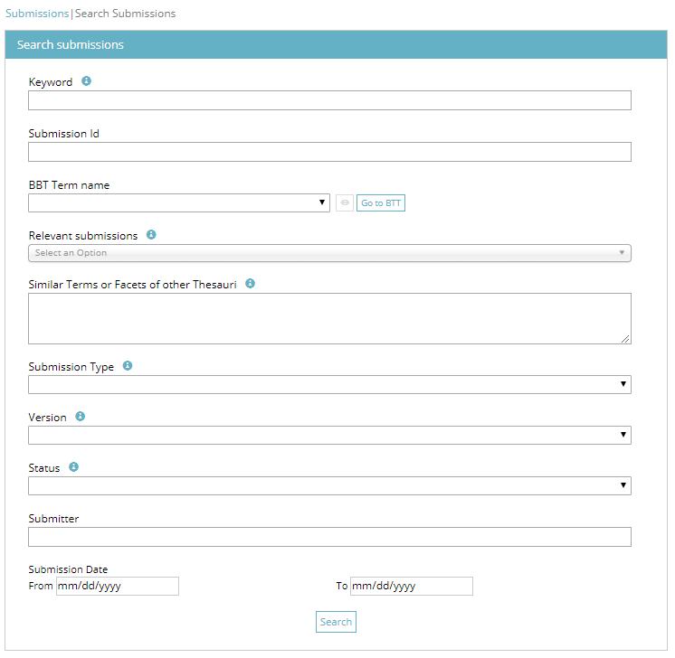
Figure 8: Form for searching submissions

Connections Tab
Users can create a connection between a BBT term and a term of their local thesaurus, using Connections tab-section. Users can also search and view connections of other users as well as send a message to the connection creator. It is also possible to edit or delete connections that belong to the user.

Connections list description
Related user role: all (applies to all the section apart of paragraphs with other indication in the beginning)
When the Connection tab-section is selected, the list of all connection entries appears in the main area (Figure 9). Connections are listed by most recent entry date.
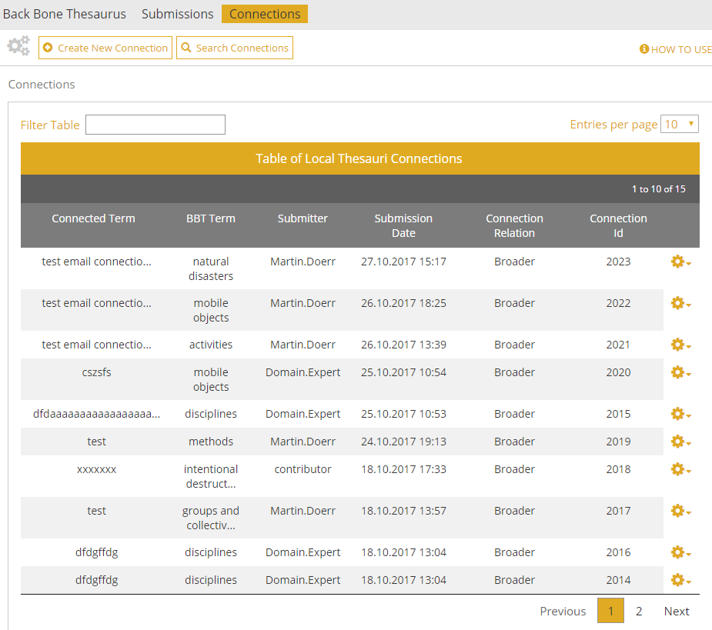
Figure 9: Connections list

Connections list filters
The user can filter connections from the filter box on the left top side of the list using keywords related to the field content that appears in the columns and rows of the table (Figure 10).
Each line of the list represents a connection of a BBT term to a term of a local thesaurus. Each column includes information related to the connections:
- Connected Term: The name of the Local thesaurus term that is connected to the BBT term
- BBT Term: The name of the BBT term to which the Local Thesaurus term is connected.
- Submitter: the person who made the connection
- Submission Date: the date when the connection was made
- Connection relation: displays how the BBT term is related to the Local thesaurus term
- Connection ID: An identification number of the connection form given automatically by the system
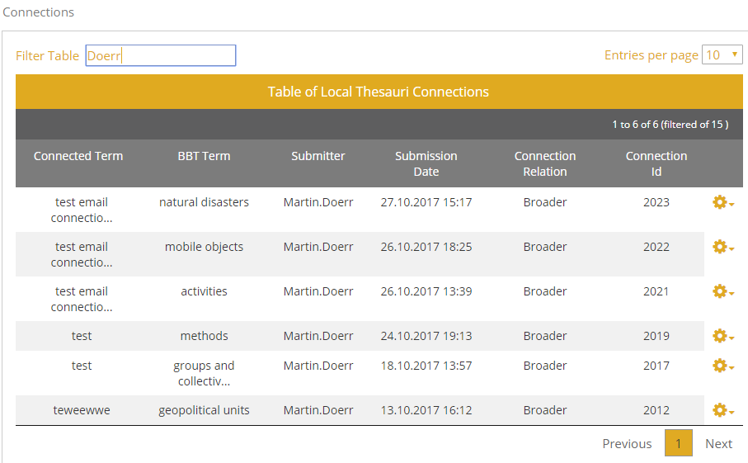
Figure 10: Connections list filtered by keyword “Doerr”
All connection lines of the list are links that lead to the Connection form in view mode.

Connections list actions
The user may select to edit or delete one of his own connections or view the BBT term. On the right side of each connection line are the related buttons (Figure 11):
- Edit Connection: (Related user role: owner) this button opens the edit mode of the connection form. Users can only edit their own connections. (Related user role: administrator) Only administrators have the right to edit other user connections.
- Delete Connection: (Related user role: owner) this button allows the user to delete the connection. Users can delete only their own connections. A warning message will appear by clicking the button. (Related user role: administrator) Only administrators have the right to delete other user connections.
- Go to related BBT term or facet: (Related user role: any) this button allows the user to view the BBT term

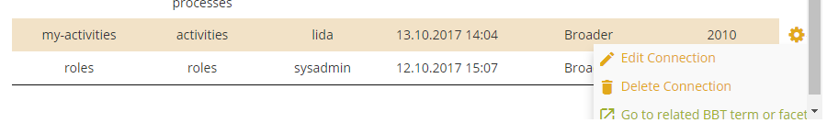
Figure 11: Connections list actions (related to own connections)
The user may select to send messages to other users related to their connections. On the right side of a connection line are the related buttons (Figure 12):
- Forward to Submitter: (Related user role: any) this button sends a message to the person that created the connection. It opens up a pop up screen allowing the user to write his message. The message includes a link to the connection form and the comment of the user. This button is visible to all users.

Figure 12: Connections list actions (related to connections of other users)

Search for connections
Related user role: all (applies to all the section apart of paragraphs with other indication in the beginning)
If the user doesn’t find easily the desired connection, it is possible to navigate to the search form from the button at the tool menu (see Figure 13).
The user can search for a connection by adding the following criteria:
- BBT Term Name
- Connected Term Name
- Connected Term URI
- Connected Term Relation
- Thesaurus Name
- Connection Id
- Submitter
- Submission date

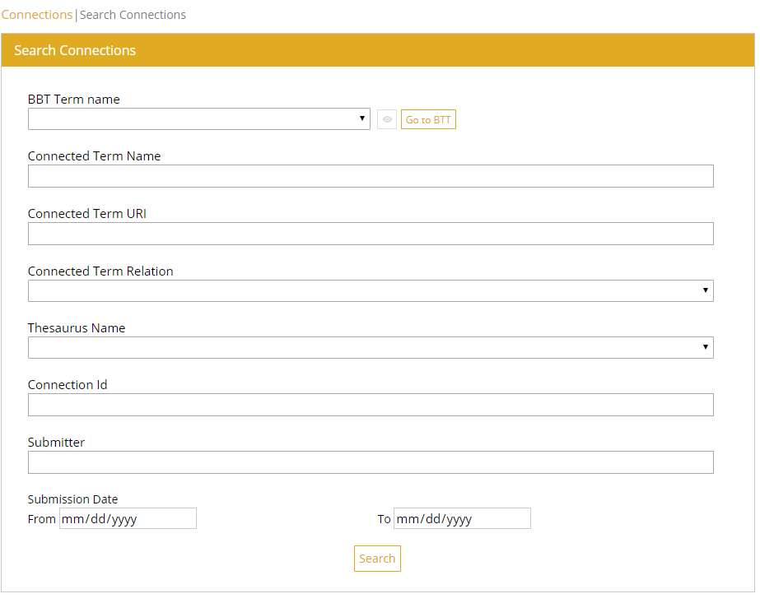
Figure 13: Connection Search Form

